AIM: You are asked to create a well-structured output for their API client using Postman, which will hit that URL and get a detailed report on the weather in a quicker way.

Collection:

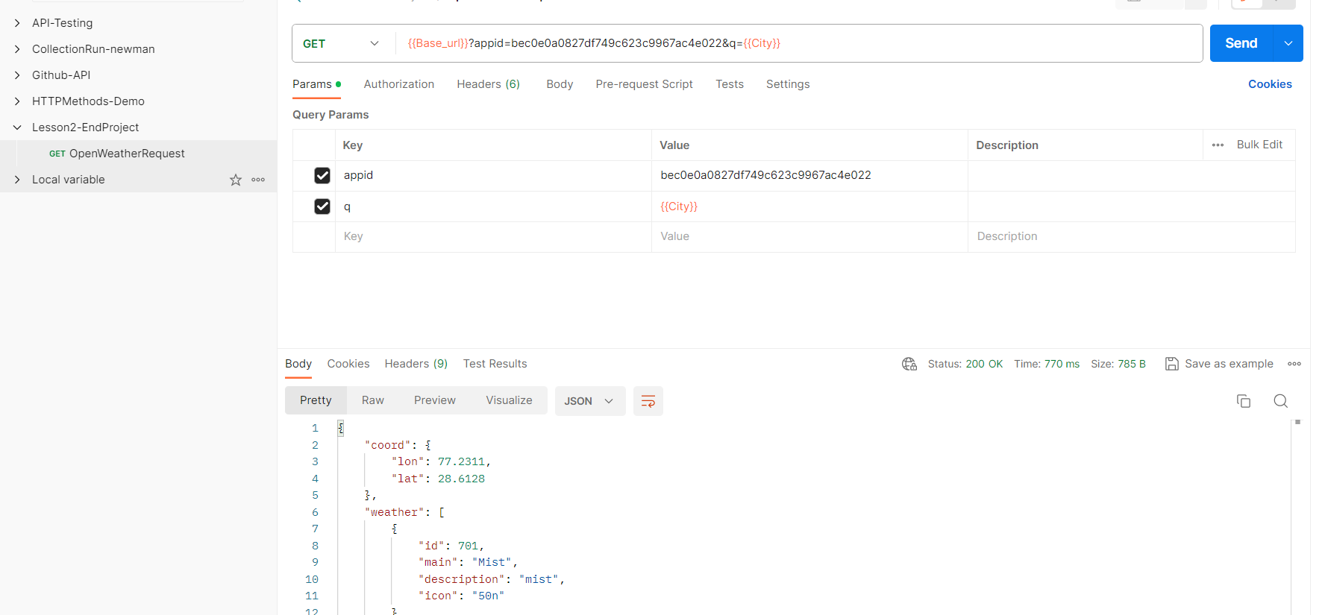

Environment:

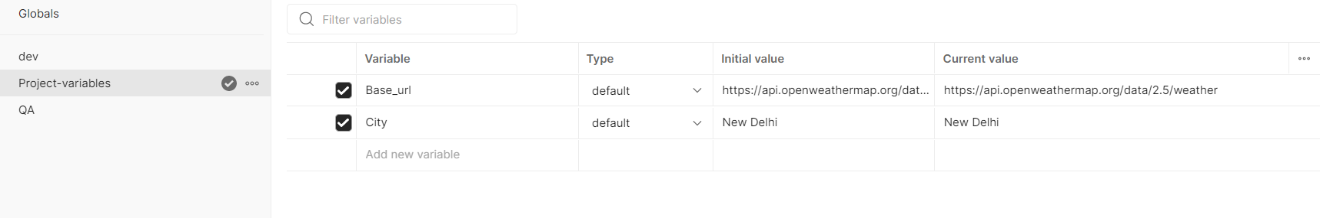

Run Result:

